|  |
| --- |
| SHANGRILA  SPA |
|  |
| ISTN3AS MILESTONE 1  Group 21  216034264 MIKARA PATHER  216002181 FARNAAZ NOORBHAI  217021772 ASHRAF BHAROOCHI  218005822 RIKESH KYLAS  218002057 MOHAMED ESSACK |

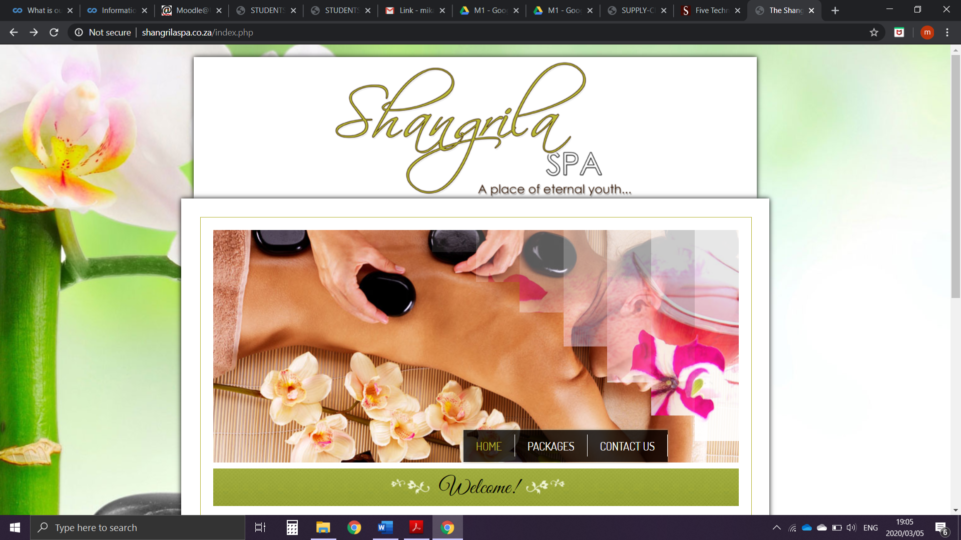CONTENTS PAGE

Problem Statement 3

Background information:

1. Client information 4

2. Business Area 5

List of features 6

Business Procedures 7

Logical models

Context level diagram 8

Level 0 data flow diagram 9

Entity relationship diagram 11

Conclusion 13

Appendix one 14

Appendix two 15

Appendix three 17

PROBLEM STATEMENT

Mrs Anneline Govender is a sole proprietor of her business. She constantly receives appointments telephonically via her website, email and social media. Appointments are recorded using the old pen and paper method whilst employee times, inventory and client information are captured through spreadsheets using Microsoft excel. There is no custom designed (or designated) electronic system/software being implemented to ensure data is being captured accordingly (reducing anomalies). The problem of maintaining data security in addition to pilferage remains an issue. The pen and paper capturing method could result in loss of data or invoices to monitor finances during the month, as well as manipulation of recorded data. This system also leaves error for multiple clashes of appointment times which could result in confusion. Using the pen and paper method can lead to mismanagement of historical appointments.

This system also leaves error for multiple clashes of appointment times which could result in confusion. Using the pen and paper method can lead to mismanagement of historical appointments. Having such a system in this business, which is outdated leads to multiple inconveniences that are high-risk to the business and can lead to potential loss in the number of clients. Keeping of track social media, products and email appointments prove to be difficult for the owner. This is due to the fact that customers decide to make last minute changes to their appointments that have been placed. Data capturing, using this particular method and software (Microsoft Excel) becomes a tedious task which is often very time consuming or inaccurate, especially with the several other tasks that she is responsible for as the sole proprietor of her business.

The limitations of the current system are:

* System is incapable of generating various reports
* System doesn’t store details of customers
* System doesn’t store details of staff
* System gets its appointments through email and social media therefore, it is prone to human error such as misinterpretation and key aspects being omitted
* System is not effective or efficient since it results in delayed replies and enquiries
* System has no method of tracking staff working hours
* It has an abundance of manual paperwork of the supplier, customer and order details which is time consuming to go through and obtain. The accumulative paperwork leads to redundant data in product information which results in confusion amongst employees and has led to concerns regarding loss of documentation.
* System does not cater for clashing of appointments
* System does not cater for clashing of masseuses’
* System is incapable of generating an invoice
* System does not convey discounts and offers

Type of System(s) we aim to develop:

• Appointment Management system

BACKGROUND INFORMATION

1. **Client Information**

Organisation name : Shangrila Spa

Owner : Anneline Govender

Manager : Anneline Govender

Trading Hours : Mon: 9am – 5pm

Tues-Thurs: 9am – 7pm

Fri & Sat: 9am – 6pm

Sun: Closed

Public Holidays: 10am – 3pm

Phone no : 061 218 9935

Physical address : Shop 6, 28th Avenue

Umhlatuzana

4092

Email : info@shangrila.co.za

1. **Business Area**

The Shangrila Spa is a beauty/therapy spa situated in Umhlatuzana established in 2011, it is an ever-growing business with thousands of clientele. Shangrila aims to provide a variety of services that range from manicures and pedicures to full body massages. Their personalised packages vary every month to give you a better spa experience on every visit. Staff are highly trained and determined to give you the best service possible. Anneline Govender is the mastermind entrepreneur behind this pioneering establishment, her knowledge of being a masseuse, makeup specialist and nail therapist abroad the world, originated from working on a tour ship during her youth as well as travelling and working further in London. Her time abroad allowed her to gain an abundance of experience and save up all her hard-earned money to venture back to South Africa where she could pursue her dreams to develop a spa of her own.

Customers of Shangrila are allowed to phone in and create appointments for various packages or treatments, they may also enquire, or order products sold by the spa. Anneline and her staff are often clustered with appointments or are too busy in treatment with other customers, this results in a time dilemma and possible conflicts of appointments when recorded on their current system. Anneline does not have a digitalised system to help her capture all the necessary information her business requires (which should also meet a set of data rules) which makes it difficult for her to keep track of products and appointments as well as the work her staff does and the money made from these services/products sold.

Shangrila gains a vast number of customers from far and wide, daily through adverts, social media, recommendations etc. Due to this great influx in clientele, the demand for product sales and booking of appointments has greatly increased which in turn resulted in a greater demand for a more efficient system to be built to meet this demand.

LIST OF FEATURES

|  |  |  |  |
| --- | --- | --- | --- |
| Feature Description | User Profile | Priority (Low/Medium/High) | No of Days to develop |
| Log into the system | Manager | High | 1 |
| Log into the system | Employee | High | 1 |
| Add new service | Manager | High | 1 |
| Change/cancellation of service | Manager | High | 1 |
| Add new package deals on services | Manager | High | 1 |
| Update discounts on package deals | Manager | High | 1 |
| Provide personal details | Employee | High | 1 |
| Add new staff details | Manager | High | 2 |
| Update staff details | Manager | High | 1 |
| Provide personal details | Customer | High | 1 |
| Add customer details | Employee | High | 2 |
| Update customer details | Employee | High | 1 |
| Make customer inactive | Employee | High | 1 |
| Enquire about services provided | Customer | High | 1 |
| Provide desired appointment details | Customer | High | 1 |
| Check appointment availability | Employee | High | 1 |
| Add appointment details | Employee | High | 1 |
| Confirm appointment | Employee | High | 1 |
| Make payment | Customer | High | 1 |
| Request invoice | Customer | Medium | 1 |
| Print invoice | Employee | Low | 1 |
| Search for customer details | Employee | High | 2 |
| View customers | Employee | High | 1 |
| Request customer details | Manager | High | 1 |
| Request staff details | Manager | High | 1 |
| View stock levels | Manager | High | 2 |
| Receive low stock notification | Manager | High | 1 |
| Request stock order form | Manager | High | 1 |
| Order stock | Manager | High | 4 |
| Update stock | Manager | High | 3 |
| Generate reports | Manager | High | 1 |
| Request reports | Manager | High | 3 |

BUSINESS PROCEDURES

The customer calls the store and enquires availability of appointment. The customer then gives their required details to the receptionist. An invoice it sent to the customer stipulating cost and treatments. A customer appointment confirmation and reminder are sent to the customer prior appointment time.

At the beginning of the day employees request their appointment schedules to see their treatments for the day. An appointment schedule is sent to the employee. At the end of the day the employees are required to input all details from completed appointments and any other required information.

At the end of the day, the manager requests from the system both the staff details and products/ services reports. This allows the manager to keep track of products and services as well as employees. Once a request for the reports is completed the system will generate and send the reports to the manager. The manager also has the task of completing product and service discounted offers for the month which will be inputted into the system and sent to the customers at the beginning of every month.

CONTEXT LEVEL DATAFLOW DIAGRAM

The context level diagram consists of 3 entities namely customer, manager and staff. The receptionist forms part of the appointment booking system (i.e. the system in the diagram) as they create and manage appointments made and is therefore not an entity. A customer will request an appointment by supplying the system with their details as well as the details of the appointment. The system then captures this information and responds by sending the customer an invoice as well as an appointment confirmation/reminder.

The staff members would request their appointments for the day and the system would respond by sending them appointment schedules. The staff members also provide the system with their details and the system stores these details. When the manager requests the staff members details the system would react by providing the manager with these staff details.

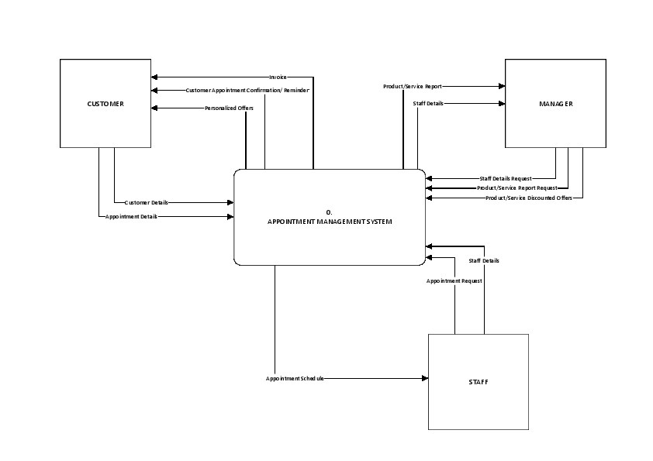The manager requests the product/service reports and the system would respond by providing these reports to the manager. The manager also provides the system with discounted product and service offers. These Products and services are provided to existing customers whenever promotional offers become available.

LEVEL 0 DATAFLOW DIAGRAM

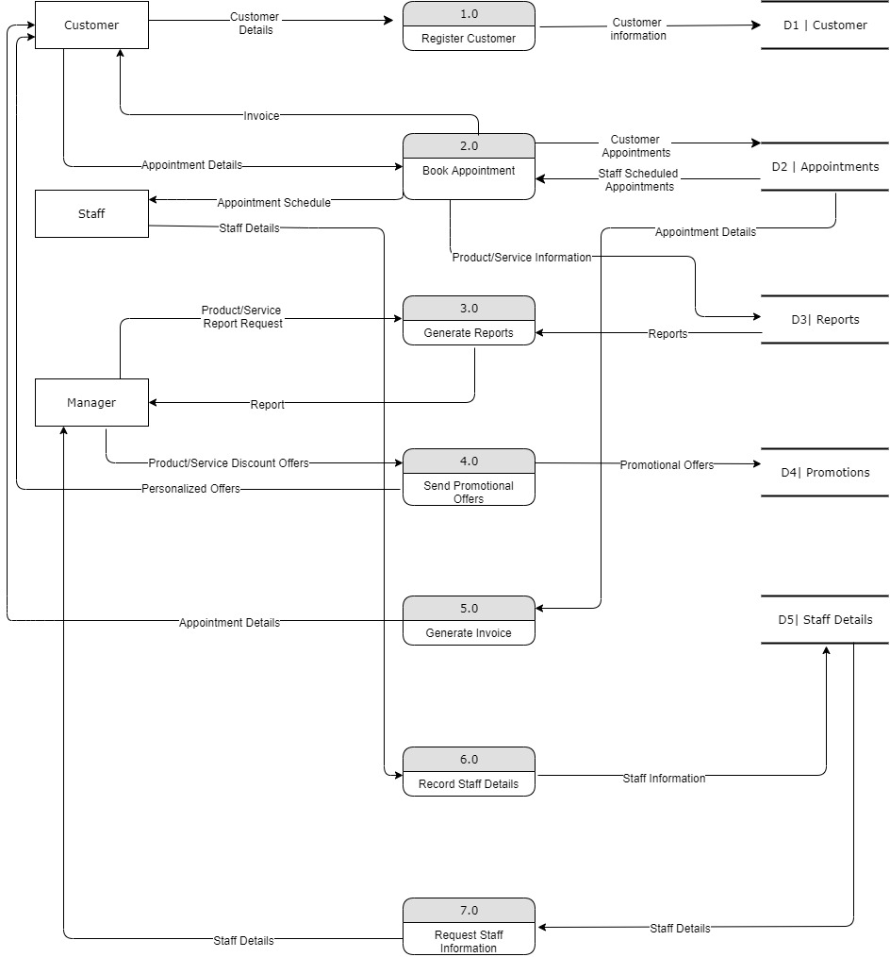

The data flow diagram above is a level 0 diagram. The process numbered 1 describes the process whereby a customer is registered. The customer provides the system with their details. The system then processes the details and stores them in a data store “customer”.

When the customer provides the system with appointment details the system stores the customers appointment in a data store (appointments). The system then responds by sending the customer an invoice. Staff members receive an appointment schedule from the system which the system gets from the data store (Reports). The manager requests information on the products and services and the system responds by providing the manager with a product service report which it gets from the data store “reports”. The manager provides discounts on products and services to the system which the system then stores in the data store “Promotions”. The system then provides the clients with these discounted offers.

Staff members input their details into the system which the system then stores in the data store “Staff”. When the manager requests staff details, the system responds by providing the manager with the staff details from the data store.

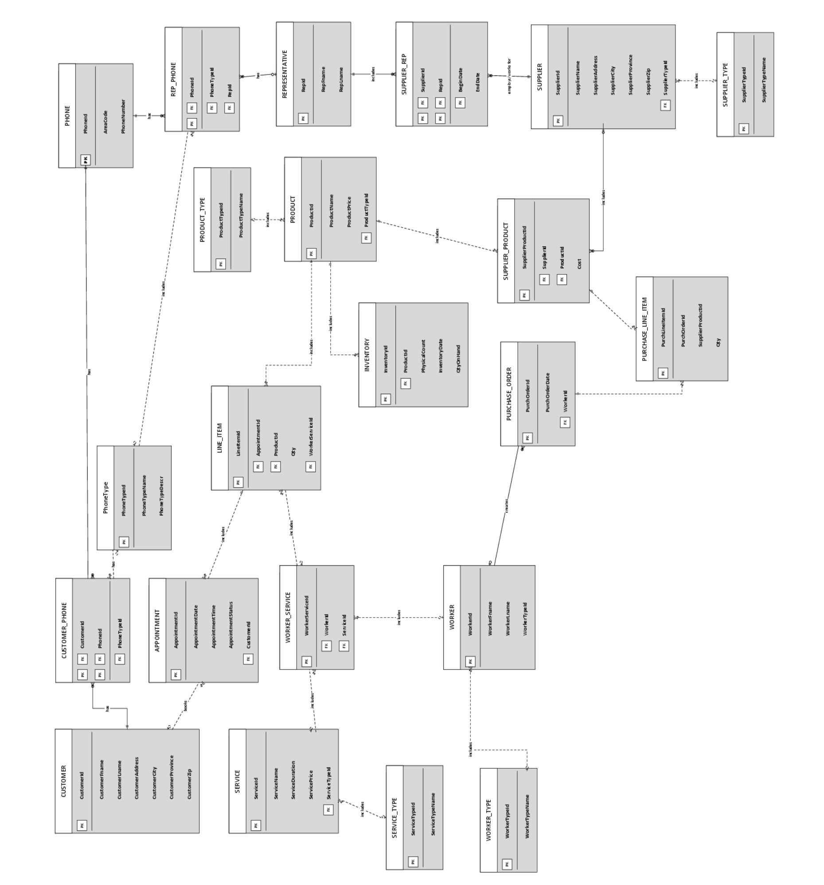

ENTITY RELATIONSHIP DIAGRAM

* A customer has 0 or many phone numbers( customer_phone)
* A customer phone number belongs to one and only one customer
* A phone type has 0 or many customer phone.
* A customer phone has 0 or 1 phone type
* A customer phone has 1 and only 1 phone.
* A phone has 0 or many customer phone
* An appointment is booked by 0 or 1 customer
* A customer books 0 or many appointments
* An appointment includes 1 and only 1 line item
* A line item is included in zero or many appointments
* A phone has zero or many rep phone
* A rep phone has 1 and only 1 phone
* A phone type includes 0 or many rep phone
* A rep phone is included in zero or one phone type
* A worker service includes zero or many line items
* A line item is included in zero or 1 worker service
* A worker includes 0 or 1 worker type
* A worker type includes 0 or many workers
* A line item includes 1 and only 1 product
* A product includes 0 or many line items
* A product includes 0 or many inventory
* Inventiory includes 1 and only 1 product
* A worker creates 0 or many pirchse orders
* A purchase order is created by zero or 1 worker
* A rep phone has 0 or 1 representatives
* A representative has 0 or many rep phone
* Supplier rep works for 1 and only 1 suppkier
* Supplier employs zero or many supplier rep
* Supplier includes zero or one supplier type
* Supplier type includes zero or many suppliers

CONCLUSION

The Current system that is implemented showed numerous flaws and problems that could hinder future growth of the business. This showed that a system is needed to be developed for the business to improve. The owner of the business will need to consider that a new system will be costly but allow the business to gain better sales, appointments and clients in the long run.

The new system will allow the business to proceed with clients in a timelier fashion than before. Invoices can assist in recording service/product sales and confusion of appointments will be minimised. The system will provide great value to the business and is seen to be a wise investment for future business growth.

APPENDIX ONE

GROUP CONTRIBUTION

|  |  |  |  |  |
| --- | --- | --- | --- | --- |
| No. | Student Number | Name and Surname | % Estimated contribution | Signature |
| 1 | 216034264 | MIKARA PATHER | 100 |  |
| 2 | 216002181 | FARNAAZ NOORBHAI | 100 |  |
| 3 | 217021772 | ASHRAF BHAROOCHI | 100 |  |
| 4 | 218005822 | RIKESH KYLAS | 100 |  |
| 5 | 218002057 | MOHAMED ESSACK | 100 |  |

APPENDIX TWO  
PROPOSED SYSTEM GUI

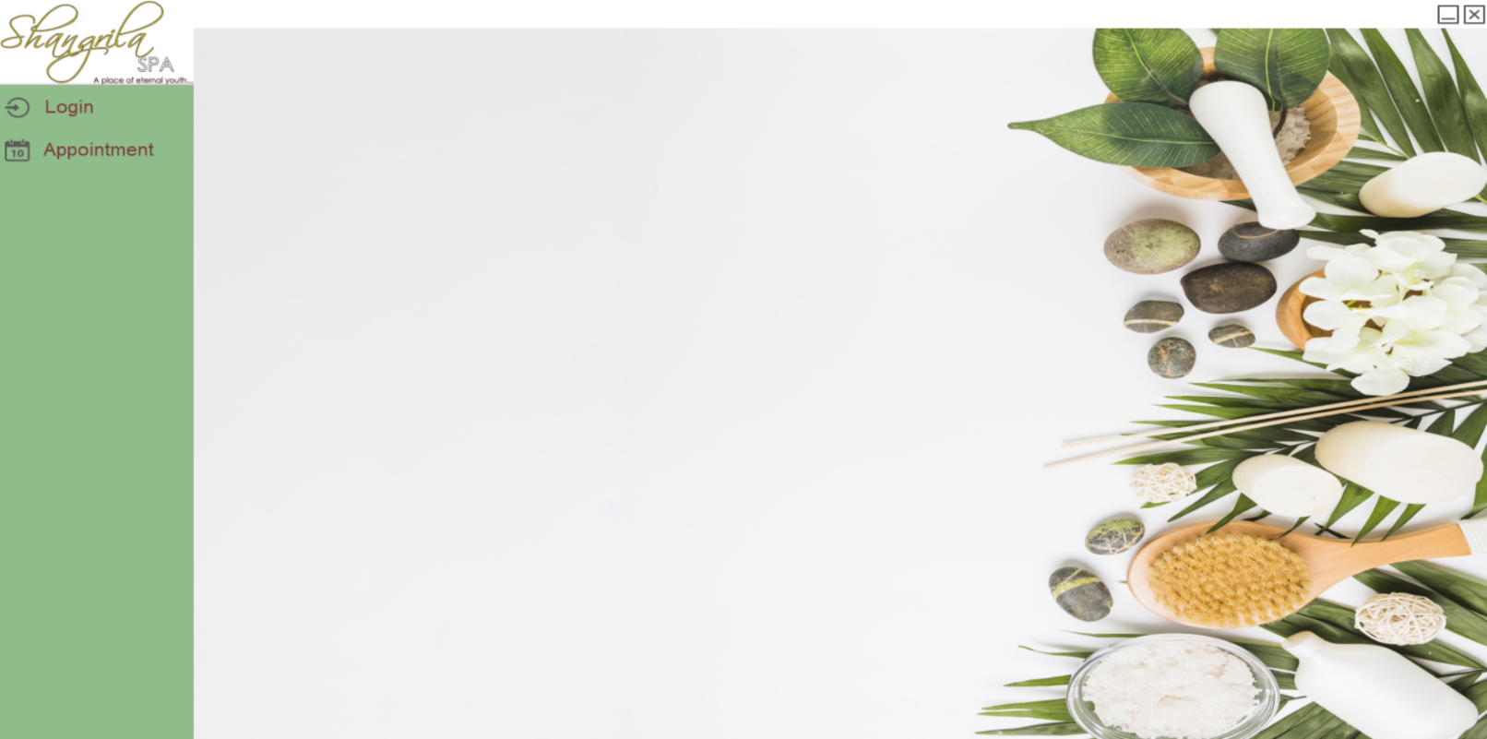

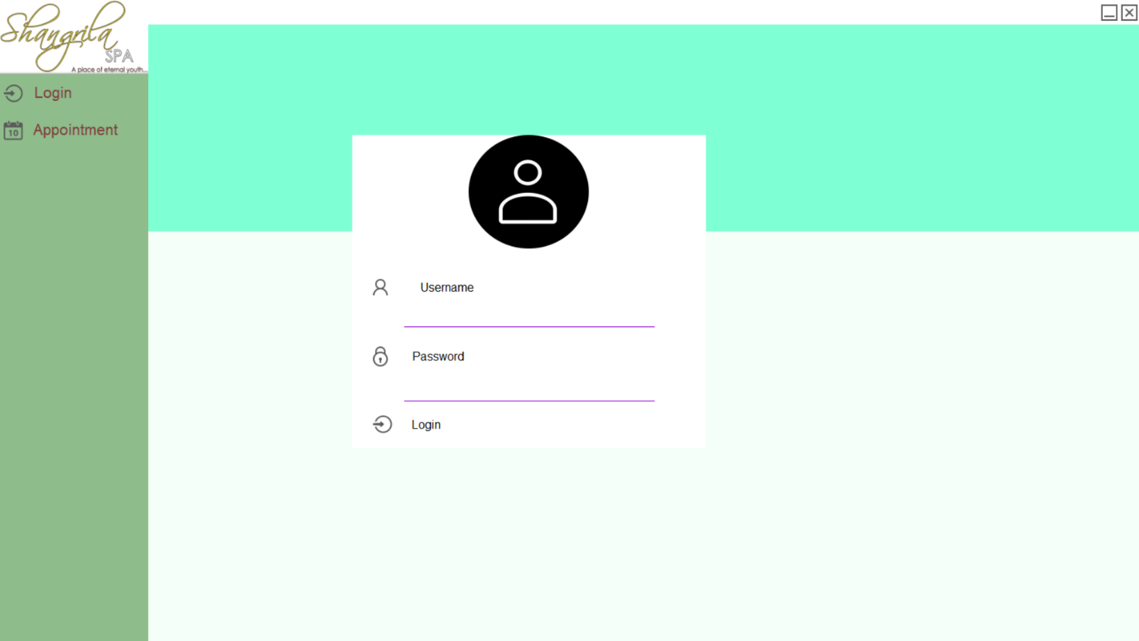

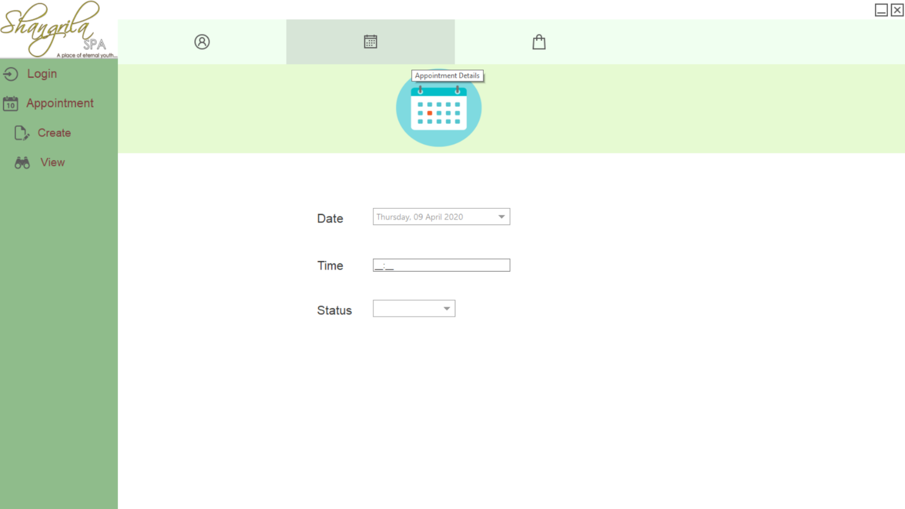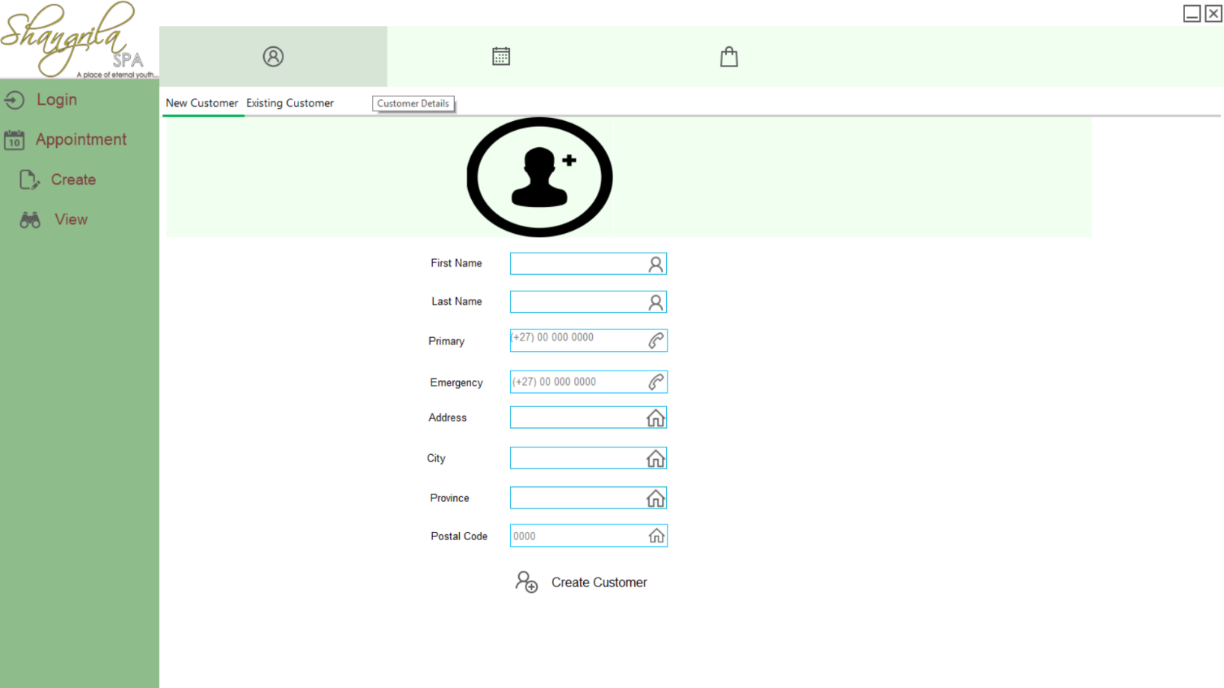

APPENDIX THREE  
VERSION CONTROL HISTORY – Additional content

USER 1 – Using Visio 2016 to create and edit the .vsdx file containing the ERD diagram used in this document.



USER 2 – No Visio access with Office 365, instead Internet Explorer is used to access this 2016 .vsdx file version of Visio.